****Tarlac State University

**COLLEGE OF COMPUTER STUDIES**

**BSIT Program - Web Development Course**

**Project Title:**

***WeFit: Your Fitness Career Partner***

A Project

Submitted to the Faculty of the College of Computer Studies

San Isidro Campus, Tarlac City,

Tarlac State University

In Partial Fulfillment of the Requirements for the Subject Web Development

Academic Year 2024-2025

Submitted By:

**Caburao, Arjay S. (Leader)**

**Cortez, Gillian I.**

**Junio, Hanie Fe Marie C.**

**Ponce, Khristine Joi V.**

**Quintanar, Aaron P.**

**Larsen B. Dignos**

Subject Instructor

Date of submission: (October 03, 2024)

Table of Contents

A. PROJECT OVERVIEW 3

A.1 Project Objectives: 4

A.2 Important Parts of the Title Proposal: 6

A.2.1 Project Scope 6

A.2.2 Conceptual Framework 6

B. TECHNICAL BACKGROUND 7

B.1 Software Development Requirements 7

B.2 Hardware Development Requirements 8

C. SYSTEM METHODOLOGY 9

C.1 Functional Requirements 9

D. PROPOSAL OUTLINE: 10

D.1 Sketch Design 10

D.2 Wireframe Design 16

D.2 Mock-up Design 35

# PROJECT OVERVIEW

|  |
| --- |
| WeFit aims to be a comprehensive online resource for fitness enthusiasts seeking personalized training guidance and support. The website's primary goal is to connect individuals with qualified personal trainers, offering tailored workout plans, nutrition advice, and motivation to achieve their fitness objectives. The target audience for WeFit includes individuals of all fitness levels, who seek personalized fitness guidance, those looking to achieve specific fitness goals, and people who prefer the convenience and flexibility of online training from beginners to seasoned athletes. This website caters to those who desire personalized training programs, nutrition guidance, and accountability to reach their fitness goals. This includes individuals seeking weight loss, muscle gain, improved overall health, or specific athletic performance enhancements, and fitness enthusiasts who are interested in learning new exercises, improving their technique, and staying motivated. WeFit is relevant and useful because it offers a convenient and effective solution for individuals seeking personalized fitness training. By connecting users with qualified trainers, we provide access to expert guidance and customized workout plans. Our platform also offers a variety of fitness programs, catering to different preferences and goals. Additionally, WeFit provides a supportive community where users can connect with like-minded individuals, share their progress, and stay motivated. |

## A.1 Project Objectives:

|  |
| --- |
| *The key objectives of this project are as follows:*   1. ***Sketch, wireframes, mockups, and prototypes*** 2. ***Design a responsive user interface*** 3. ***Develop a static website*** *for fitness that presents its various aspects which focuses on the improvement of workout professionals and enthusiasts.*   To develop a system that integrates “***WeFit: Your Fitness Career Partner”*** in terms of the following module:  *3.1.1 Home*  *3.1.2 Tagline*  *3.1.3 Brief Information*  *3.1.4 About Us*  *3.2.1 Services and Offers*  *3.2.1 Membership*  *3.2.1.1 Register / Sign up*  *3.2.2. Shop*  *3.2.2.1 Equipment Items*  *3.2.2.2 Add to Cart*  *3.2.2.3 Buy Now*  *3.2.2.3 Check out*  *3.2.3 Fitness Program*  *3.2.3.1 Workout Programs*  *3.2.3.1.1 Kinds of Workout*  *3.2.3.1.2 Rep and Set of Workout*  *3.2.3.1.3 Target and Benefit of Workout*  *3.2.4 Free Workout Videos*  *3.2.4.1 Workout Videos*  *3.2.5 Nutrition Guidelines*  *3.2.5.1 Food Guidelines*  *3.2.5.2 Lifestyle Guidelines*  *3.2.5.3 Supplement Intakes*  *3.2.6 Hire Trainer*  *3.2.6.1 Choose a Trainer*  *3.2.6.2 Hire a Trainer*  *3.2.6.3 Choose Schedules*  *3.2.7 About Us*  *3.2.7.1 About Us*  *3.2.8 Contact*  *3.2.8.1 Contact*   1. ***visually appealing and easy-to-navigate website*** |

## A.2 Important Parts of the Title Proposal:

### A.2.1 Project Scope

|  |
| --- |
| This project aims to develop a fitness trainer website to help people who want to start their fitness journey. This website will offer and serve services according to what our clients or users need or want to achieve.  This website will offer a fitness trainer that a client can hire, they have the power to choose what fitness program they want to undergo and what trainer they desire to hire a trainer that they can trust, or can be comfortable working with, our trainers also come with schedules that clients can choose from those suites their schedules    This website also offers e-commerce where you can order some gym equipment that you need for your home workouts, it also provides a free fitness program for our clients who don’t have the money or time to hire a trainer and it also provides a nutrition guide that our clients can follow for their fitness workout journey |

### A.2.2 Conceptual Framework

|  |
| --- |
| Figure 1. Conceptual Framework  This project is for developing a fitness website, from identifying user info to long-term outcomes impacting users and their fitness journey. Through careful planning, user-centered design, and constant evaluation, the website aims to provide personalized fitness solutions promoting lasting physical and mental health improvements.   As users progress, healthier habits will be built, leading to behavioral changes and a stronger sense of community. The project will benefit from expansion opportunities, contributing to innovation and inclusivity in the fitness sector. |

# B. TECHNICAL BACKGROUND

## B.1 Software Development Requirements

|  |  |  |
| --- | --- | --- |
| **SOFTWARE** | **Image / Icon** | **DESCRIPTION** |
| **Window 10 Operating System** |  | PC/Laptop Developer Operating System Windows 10 is a popular operating system for software development, widely used by developers. It offers broad compatibility with various applications and development tools, making it easy to work on different projects. |
| **VS code** |  | Use of software for system development Visual Studio is a popular integrated development environment (IDE) it is user-friendly interface helps development process and enhances overall productivity. |
| **HTML, CSS and JavaScript** |  | Used to create a program. HTML structures the content on the web, CSS controls the visual presentation of HTML elements, and JavaScript is a programming language that adds interactivity to web pages. Together, these technologies enable developers to build functional, attractive, and interactive websites. |
| **Figma and Canva** |  | Used to create a prototype and Sketch design  Figma prototyping and Canva for quick sketch designs, our group can improve collaboration, and design process, and create visually appealing, user-friendly websites. These tools help us effectively combine functionality and aesthetics, resulting in a more efficient web development workflow. |
|  |  |  |

The table above presents the information about various software tools we used in developing the system.

## B.2 Hardware Development Requirements

|  |  |  |
| --- | --- | --- |
| **HARDWARE** | **Image / Icon** | **SPECIFICATION** |
| **Desktop Computer / Laptop** |  | **intel i5, NVidia GeForce RTX, 8GB ram, 512 SSD** |
| **Smart Phone** |  | **Infinix Smart 8 Unisoc T606 4GB RAM 128 GB ROM** |

The table above shows the Hardware that was used to develop the wireframe, mockup, and prototype of our system. As the minimum requirement to build a system is a dual-core processor, 4GB ram at least 30GB HDD, it is preferable to use a quad-core processor, 8GB RAM, and 250GB SSD for faster access and smother performance. Also, a budget-friendly smartphone was utilized in the development process. Its Unisoc T606 processor, coupled with 4GB RAM and 128GB ROM, provided sufficient processing power and storage for the wire framing, mock-up, and prototyping phases. While not as powerful as the desktop computer, the Infinix Smart 8 proved to be a valuable tool, especially for designing.

# C. SYSTEM METHODOLOGY

## C.1 Functional Requirements

This Table Displays the Requirements description, priority, and complexity of our website for the user to understand all the functionalities and priority needed for this website

Table 1. Functional Requirement for Clients/Members Module

| Req.ID | Requirement Description | Priority | Complexity |
| --- | --- | --- | --- |
|  | Clients should be able to navigate everything effortlessly   * Display the Home page with our logo, tagline, and Button that connects to the other pages | High | Medium |
|  | Clients should be able to access all the services our website offering   * Clients should easily access all the features of our website including the home page, shop, fitness program, nutrition guidelines, free fitness video, checkout section, hiring a private trainer, contact and about us | High | Low |
|  | Clients should be able to register for our exclusive membership   * Clients should be able to register or sign in to our membership if they want to, so they can avail of some of our exclusive offers | High | Medium |
|  | Clients should be able to access our about us and contact   * Clients should be able to access our about us and contact page so they can see what WeFit all is about and be able to contact us if there are any inquiries | High | Low |
|  | Clients should be able to access our shop which contains the following:   * Add to cart items * Check out items * Browse for specific items | High | Medium |
|  | Clients should be able to access our hire trainer which contains the following:   * Hire the desired trainer * Fill up the form for hiring a trainer * Choose what schedule you desire | High | Medium |
|  | Clients should be able to access our nutrition guidelines which contain the following:   * Food guidelines such as calorie and protein intake * Supplement consumption * Lifestyle tips | High | Low |
|  | Clients should be able to access our Fitness Program which contains the following:   * Program set * Workout counts and reps * Workout target and benefits | High | Medium |
|  | Clients should be able to access our Free Fitness Video   * Clients can watch free workout videos for them to do at home | High | Low |
|  | Display Services and Offers   * Provide Clear Information about all the services and offers our website has | High | Low |
|  | Trainers Information   * Provides clear information about the trainer such as contact info, expertise, and schedules available | High | Low |
|  | Shop Items, Check out, and Price   * Items should be quality and in the best shape or not used * Check out process should be easy to settle * Equipment’s Price should be reasonable and accurate | High | Medium |
|  | Programs   * The set of workouts should be accurate to the main target muscle you want to work on | High | Medium |
|  | Contact and About Us   * Provide the Contact Information like names, email, addresses and valid contact number * Provide Clear Information to what this website is all about including objectives and Scope | High | Medium |

# D. PROPOSAL OUTLINE:

# D.1 Sketch Design

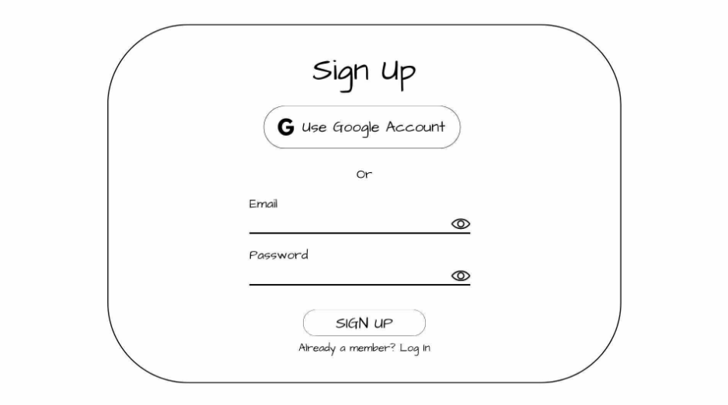

Figure 1. Sign Up / Registration Page

This is the sign-up or registration page for a website or application. Users can choose to sign up using their Google account or by providing their email address and password. If they are already registered, they can log in.

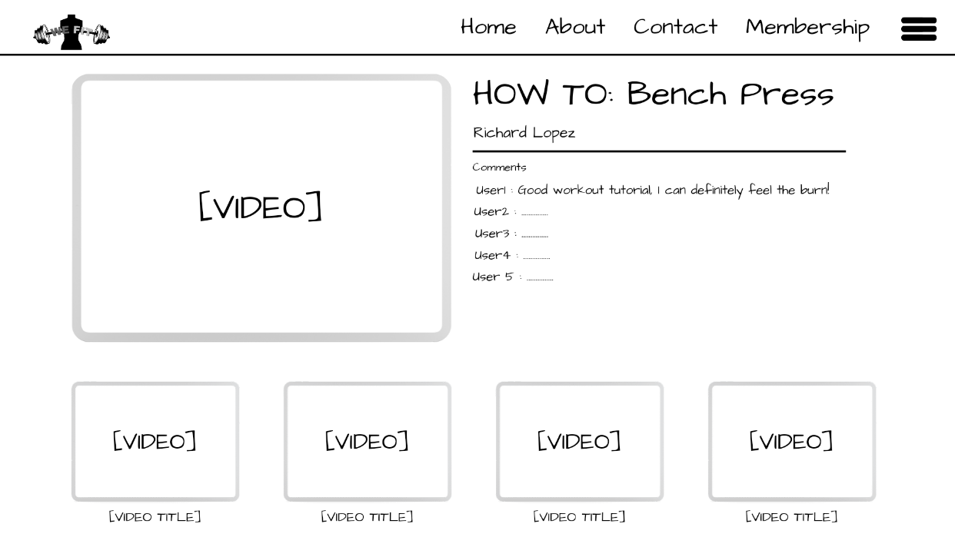

Figure 2. Workout Page

This page features video demonstrations, followed by a section for comments from users.

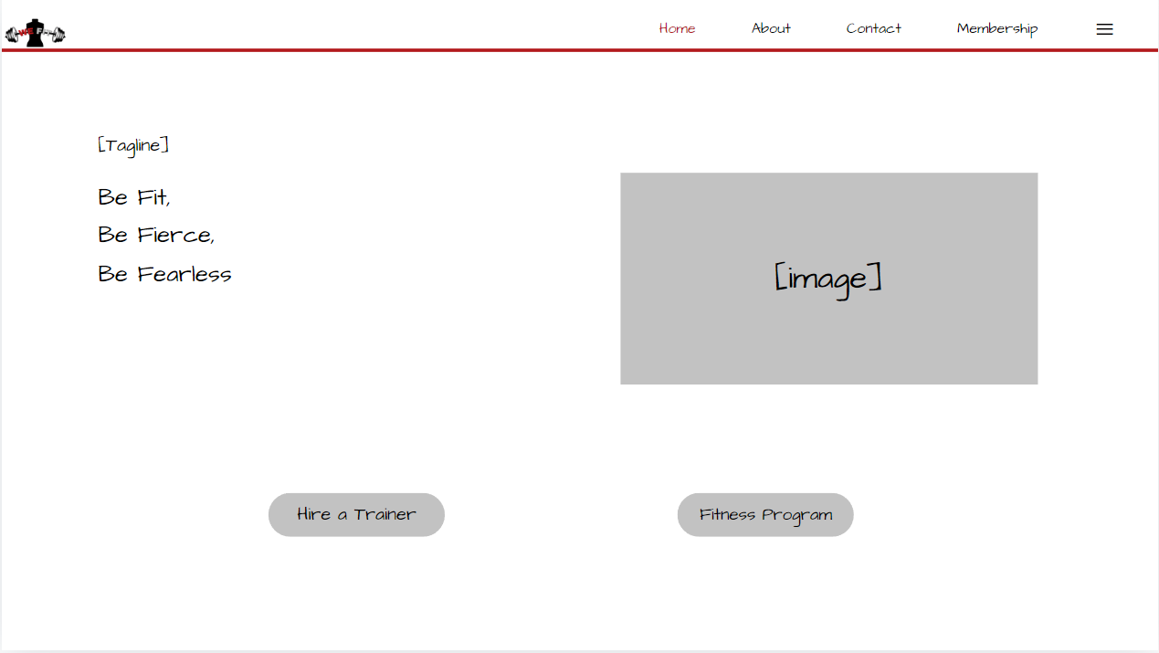

Figure 3. Home Page

This is the home page of our fitness website. It features our tagline "Be Fit, Be Fierce, Be Fearless," a large placeholder for an image, and two buttons: "Hire a Trainer" and "Fitness Program." The navigation bar at the top includes links to the home page, about page, contact page, membership page, and a menu icon.

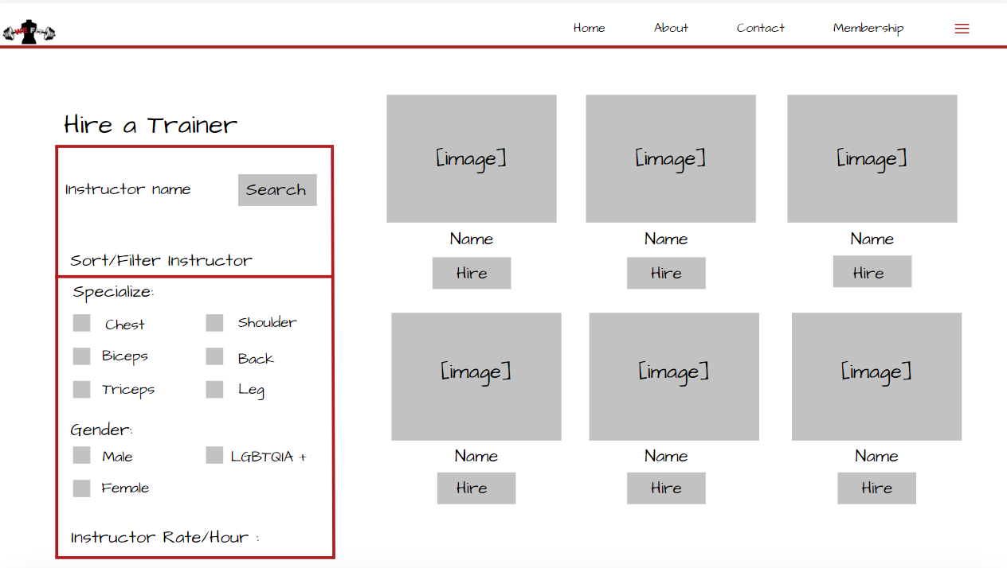

Figure 4. Hiring Page

This page features a search bar to find instructors, filters to narrow down the search by specialization, gender, and hourly rate, and a grid of instructor profiles with their names, images, and a "Hire" button.

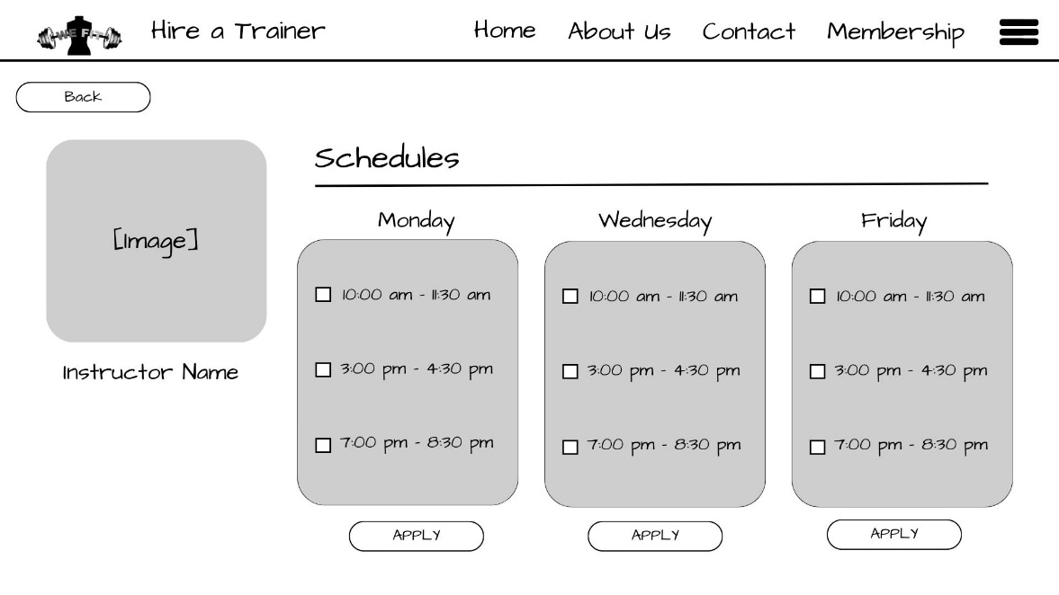

Figure 5. Schedule Page

This page allows users to view the available training schedules for different days of the week. Users can also apply for a training session by clicking the "APPLY" button.

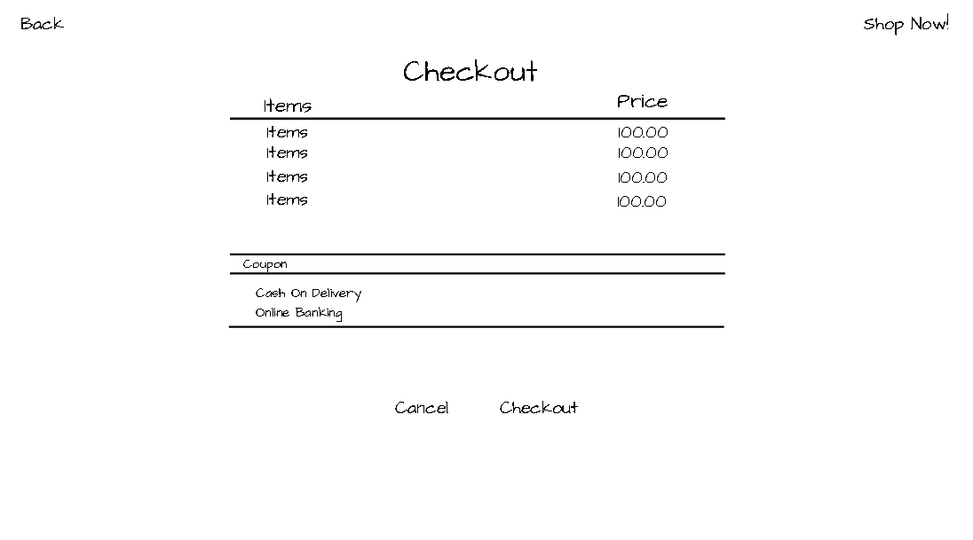

Figure 6. Checkout Page

This page displays the items purchased, their prices, and the total amount due. Users can also apply a coupon code, choose their payment method (Cash on Delivery or Online Banking), and proceed to checkout or cancel their order.

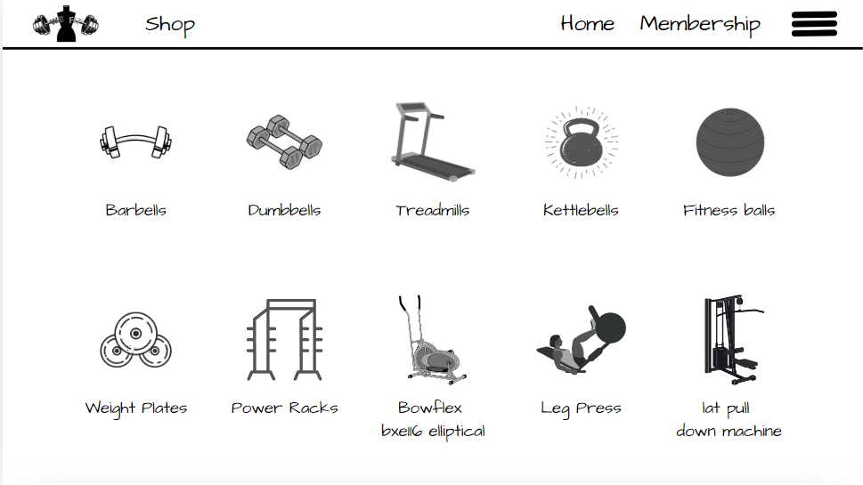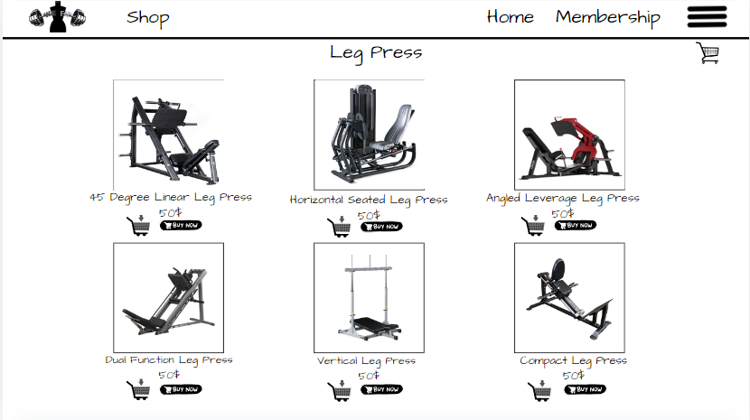

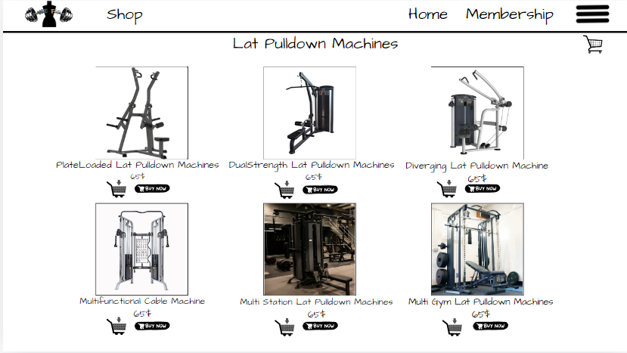

Figure 7. Shop Page

This page features categories of different fitness equipment, such as barbells, dumbbells, treadmills, kettlebells, and more.

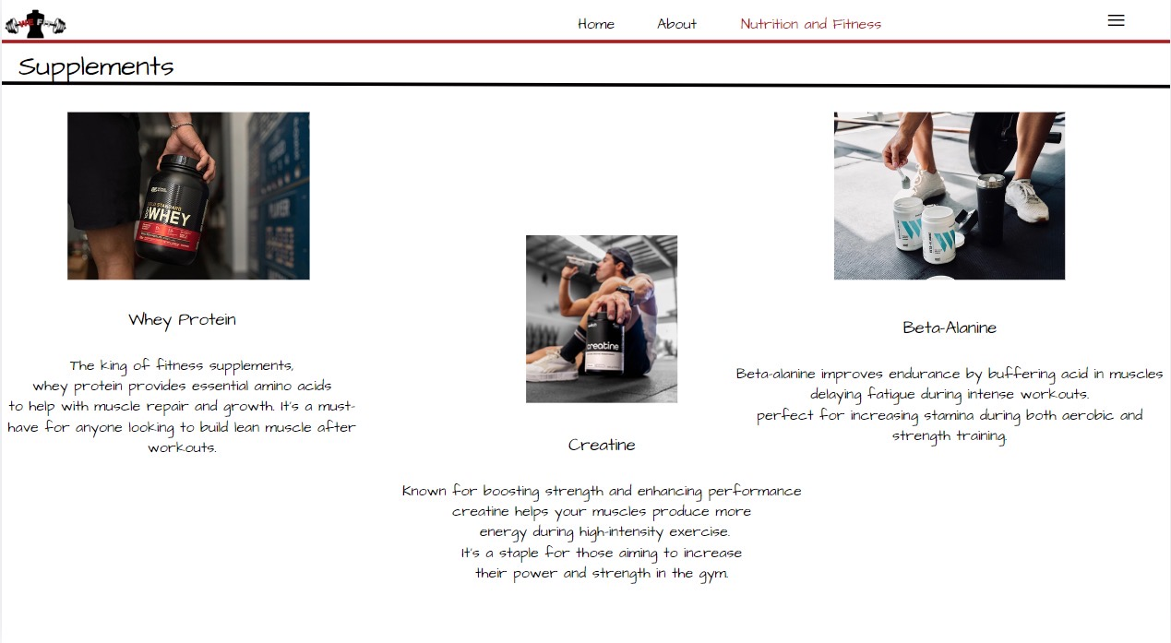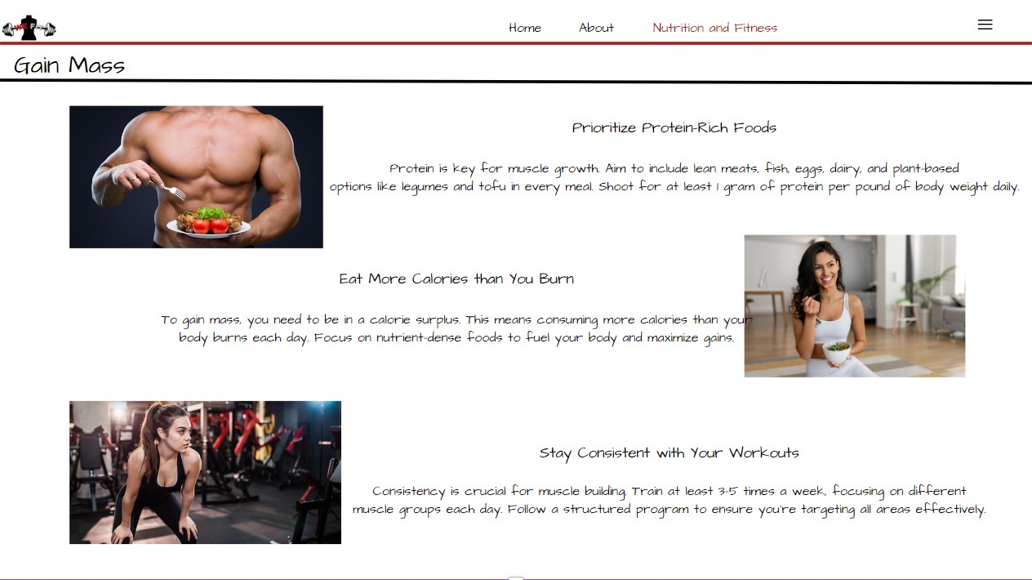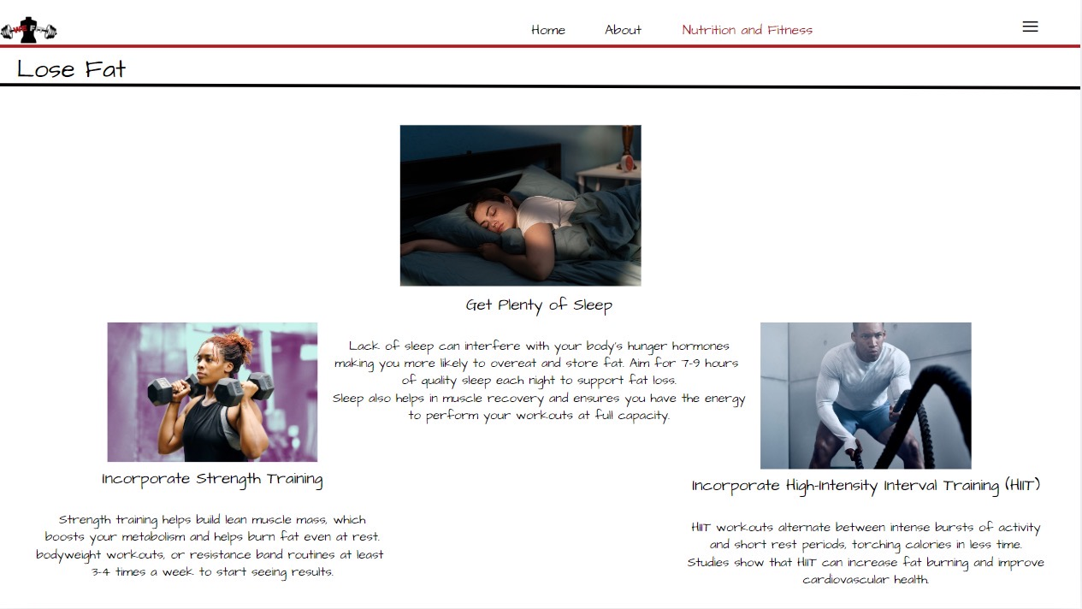

Figure 8. Nutrition Guides Page

This page features provides a resource for individuals looking to improve their diet and overall well-being.

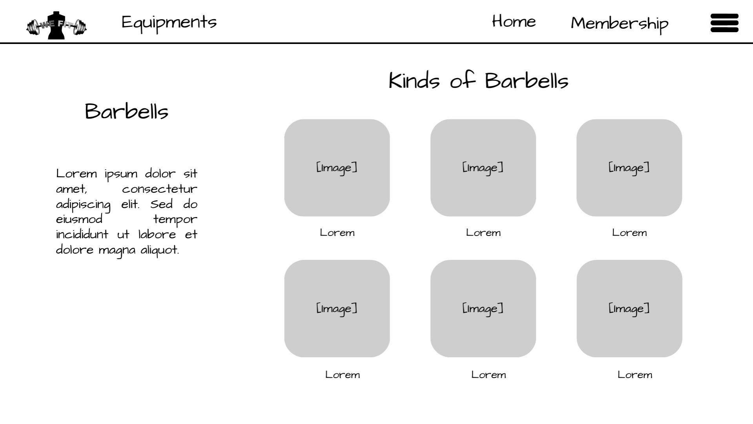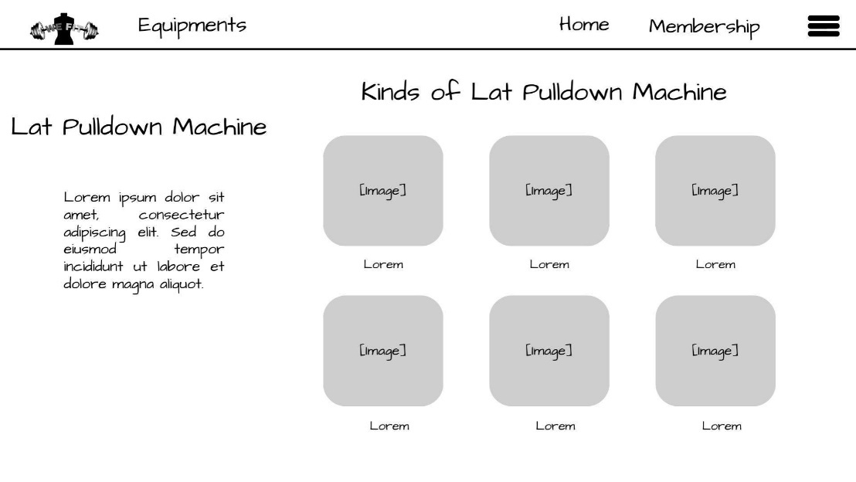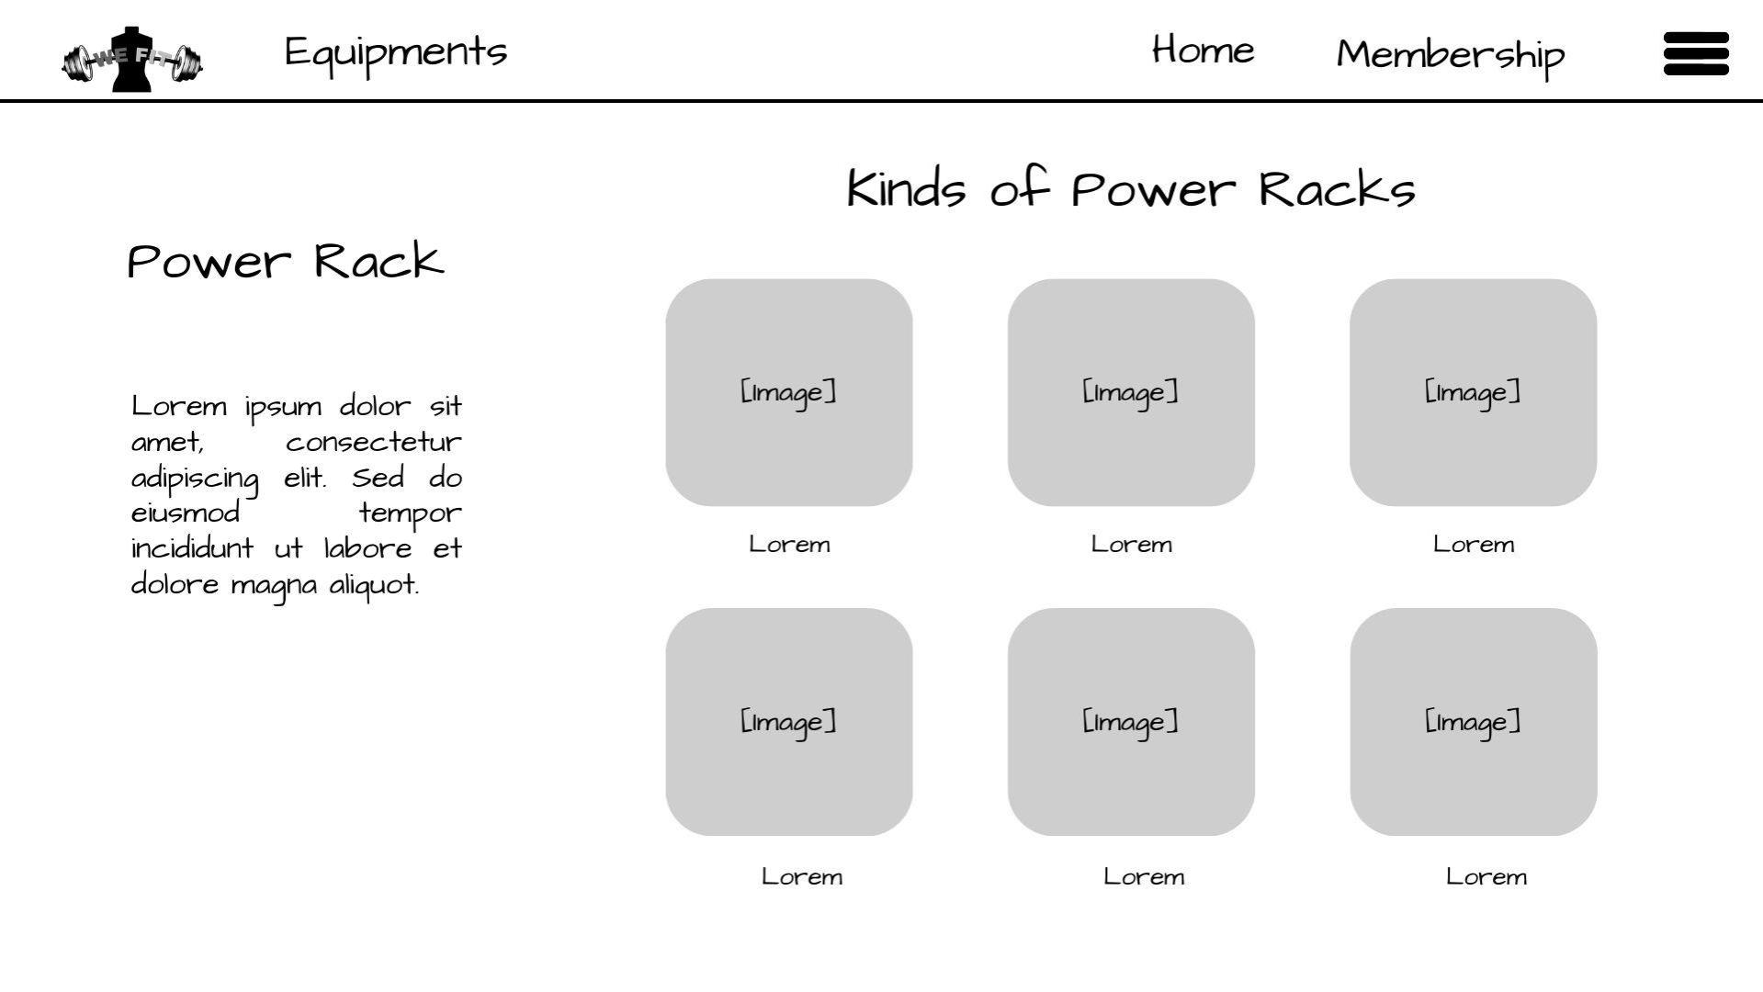

Figure 9. Equipments Information Page

This page features information about the equipment and the equipment itself.

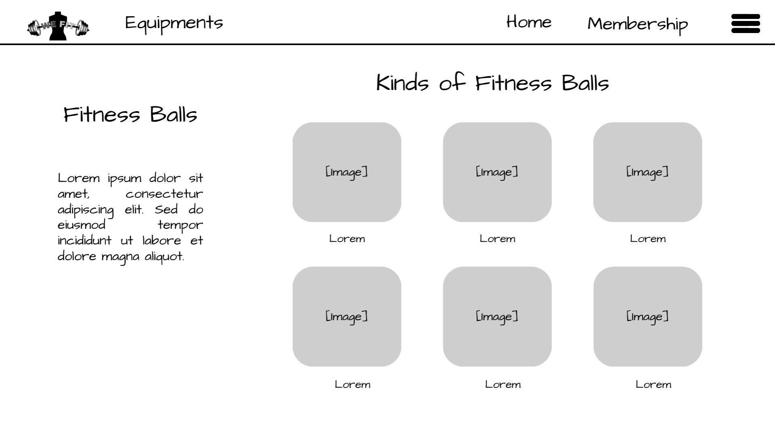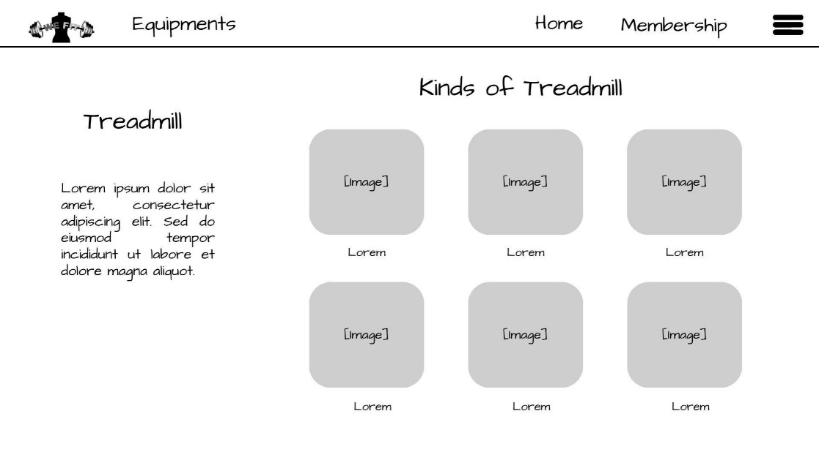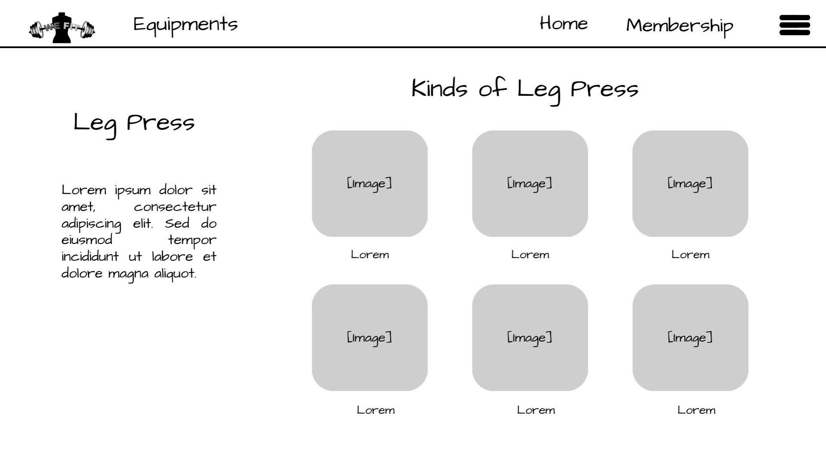Figure 10. Equipments Information Page (cont.)

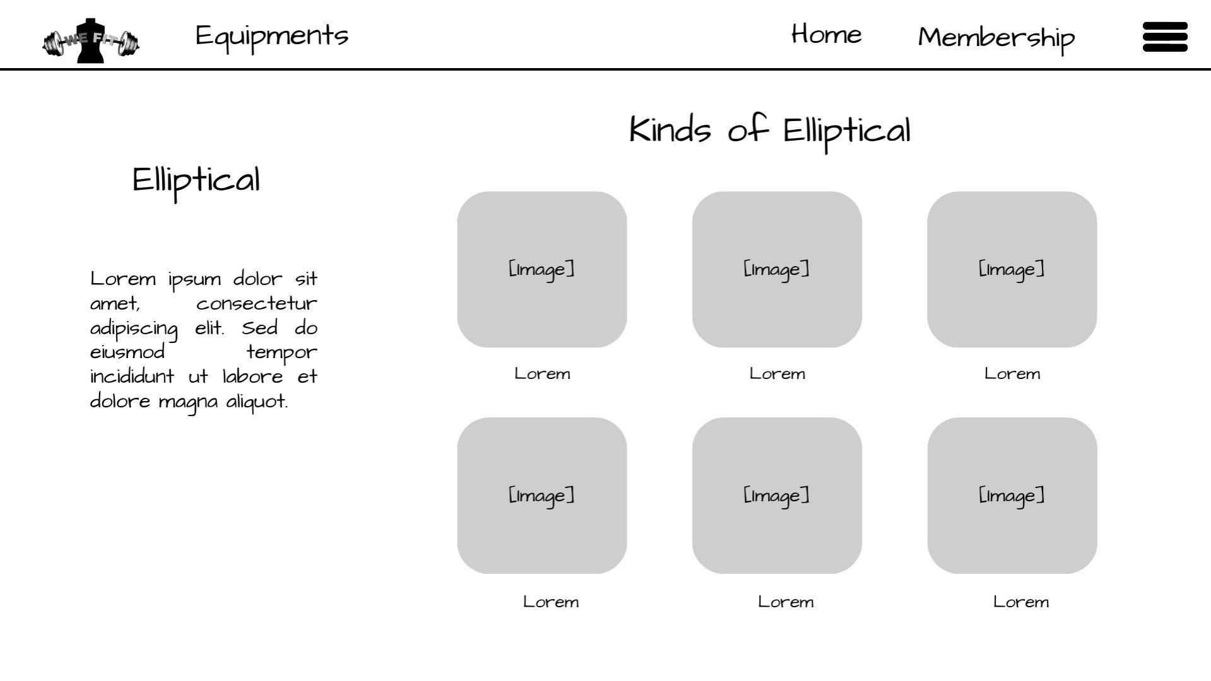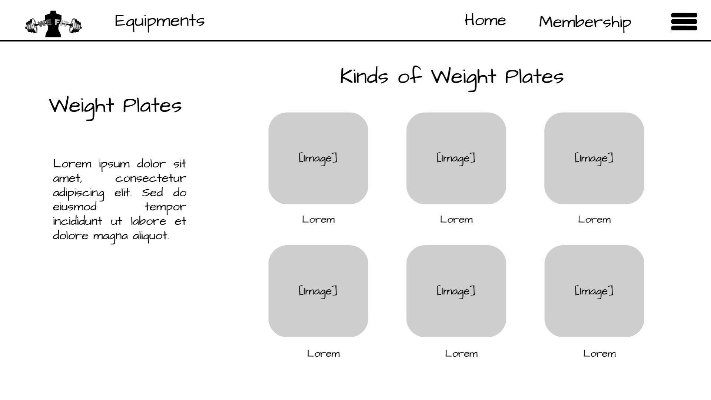Figure 11. Equipments Information Page (cont.)

## 

Figure 12. Equipments Information Page (cont.)

## D.2 Wireframe Design

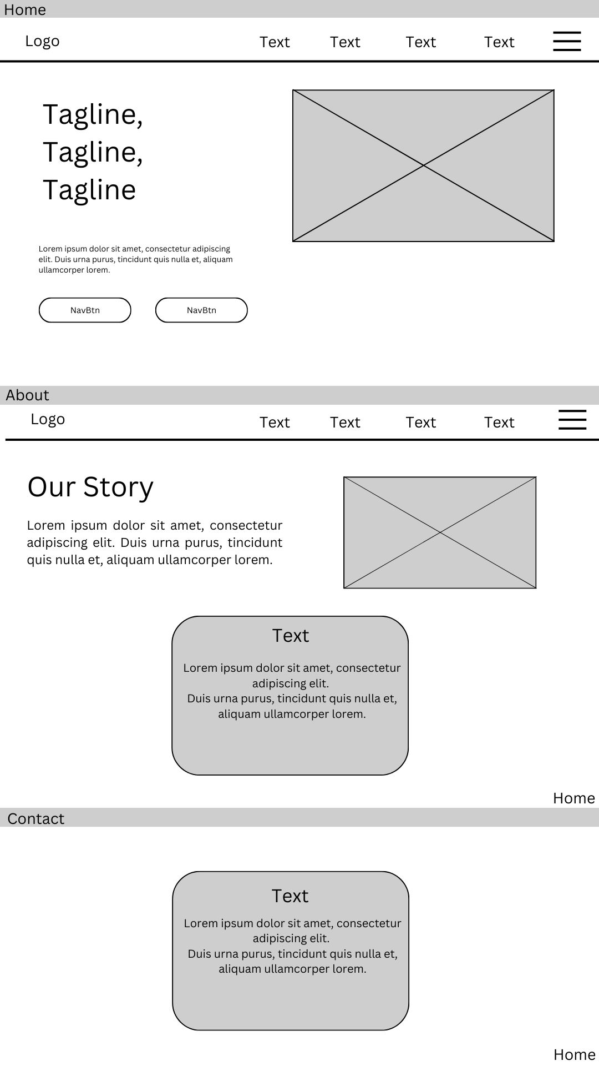

Figure 1. Home, About & Contact page

This page includes a prominent logo, a tagline, a navigation bar, and placeholders for content. The overall layout we wanted it to be well-organized and easy to navigate, providing a solid foundation for the website's design.

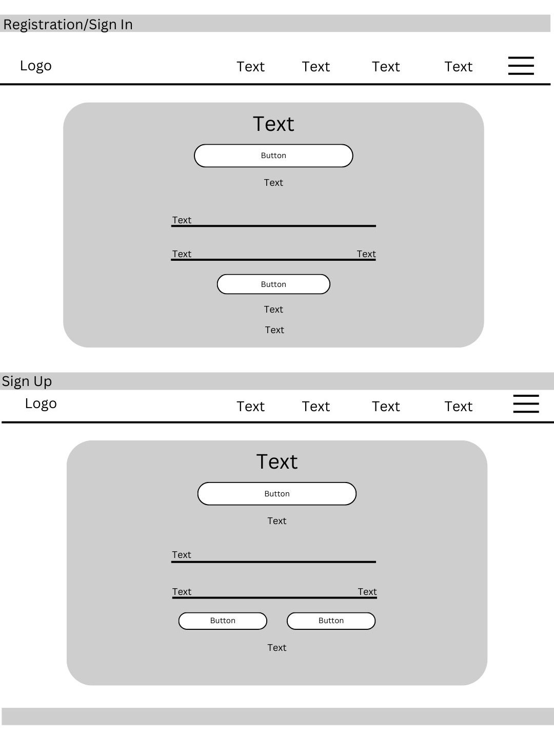

Figure 2. Sign-up / Registration Page

This page includes input fields for user information and buttons for signing up or logging in.

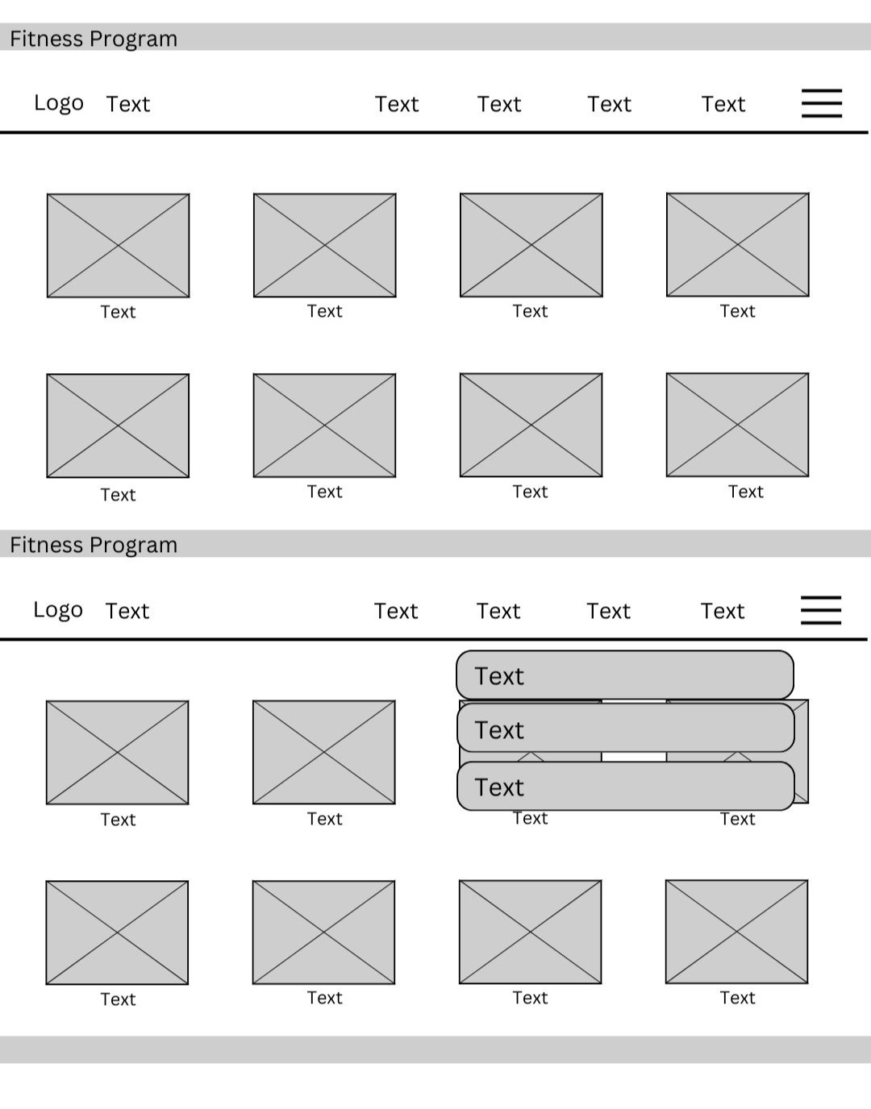

Figure 3. Fitness Program Page

This page features a grid-based layout with placeholders ***for program cards***. The cards likely represent different fitness programs offered by the platform, allowing users to easily browse and select the program that best suits their needs.

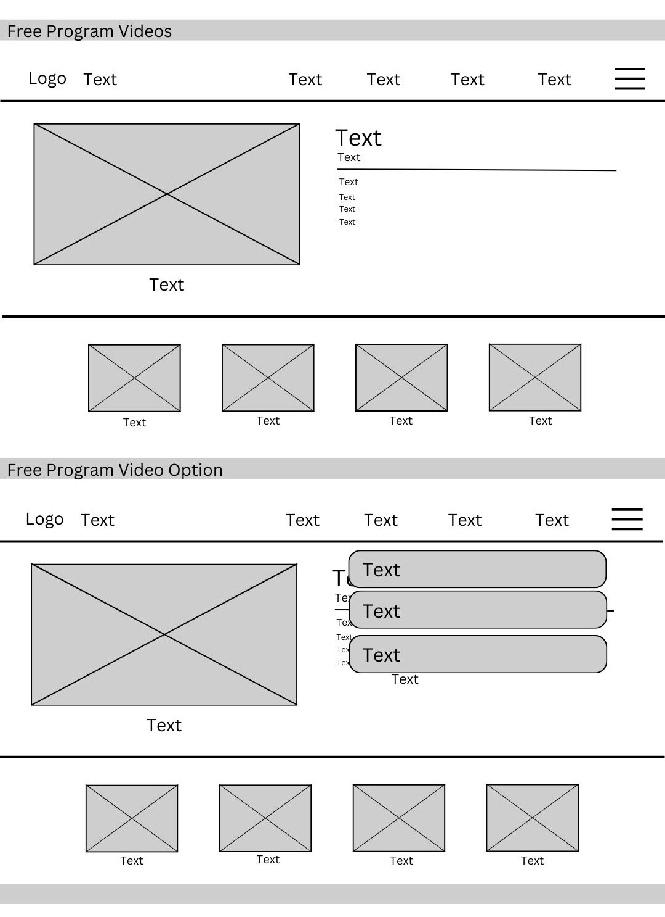

Figure 4. Program Videos Page

This page features a grid-based layout with placeholders for ***the video thumbnails and the option***. The page likely allows users to browse and select free program videos, providing additional resources to complement the free fitness programs offered by the platform.

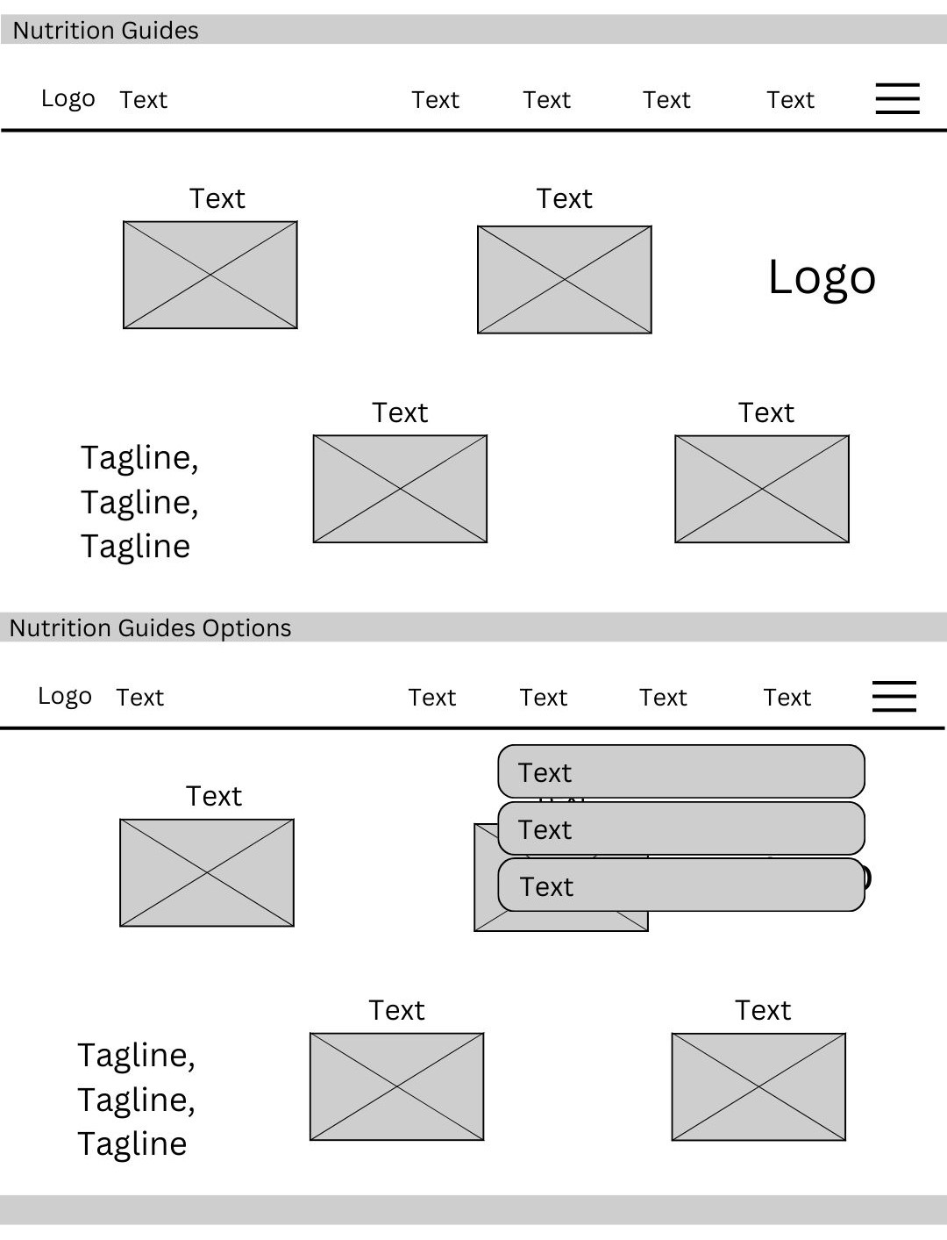

Figure 5. Nutrition Guides Page

This page features a grid-based layout with placeholders for ***nutrition guide cards***. The cards likely represent different guides or resources related to nutrition, such as macronutrient intake, meal planning, or healthy eating habits. The page also includes a section for nutrition guide options, suggesting that users can filter or search for specific guides based on their needs.

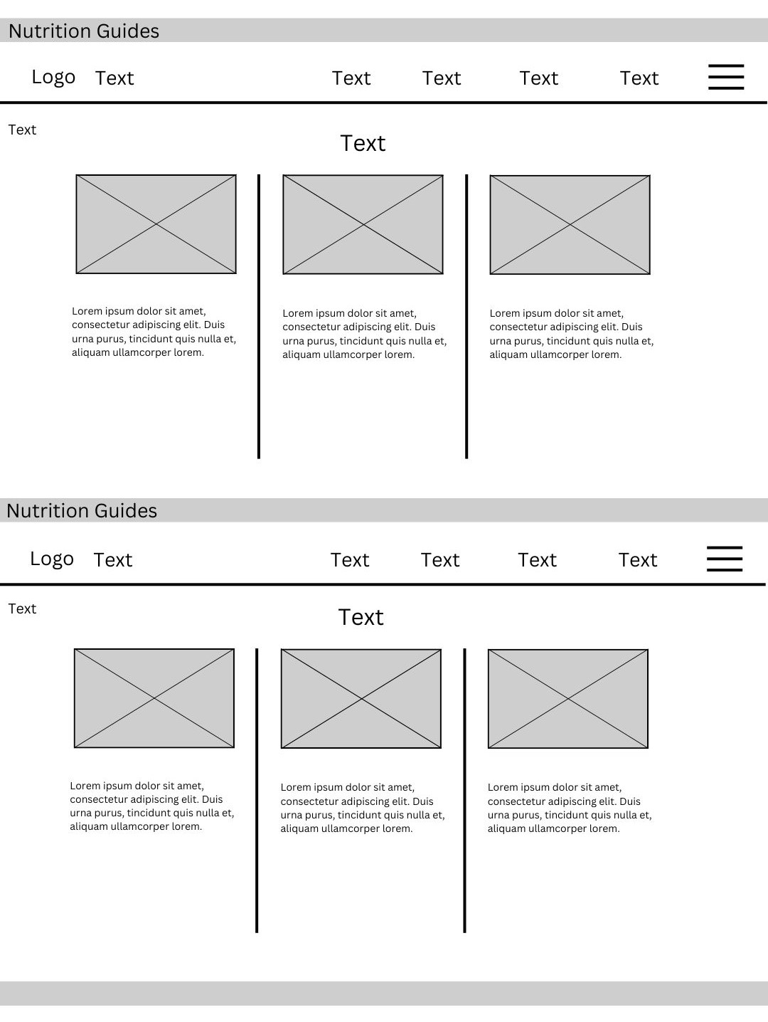

Figure 6. Nutrition Guides Page (cont.)

This is the continuation of the Nutrition Guides Page. It features a similar grid-based layout as the previous section. It likely includes additional nutrition guides or resources, providing users with a wider range of information and options. The consistent design elements, such as the navigation bar and logo, maintain an easy user experience throughout the website.

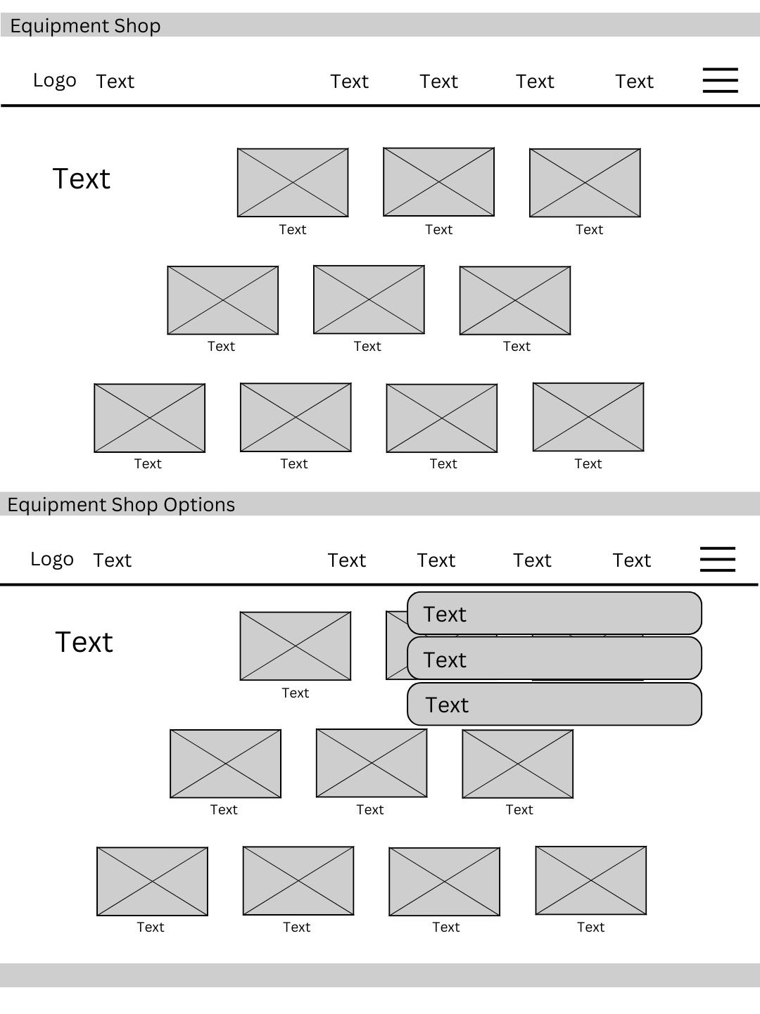

Figure 7. Equipment Shop Page

At this page, it features a grid-based layout with placeholders ***for products***. The rectangle-like images likely represent different fitness equipment items available for purchase, with information such as product images, descriptions, and pricing. This page also includes a section for equipment shop options, suggesting that users where the option would be seen.

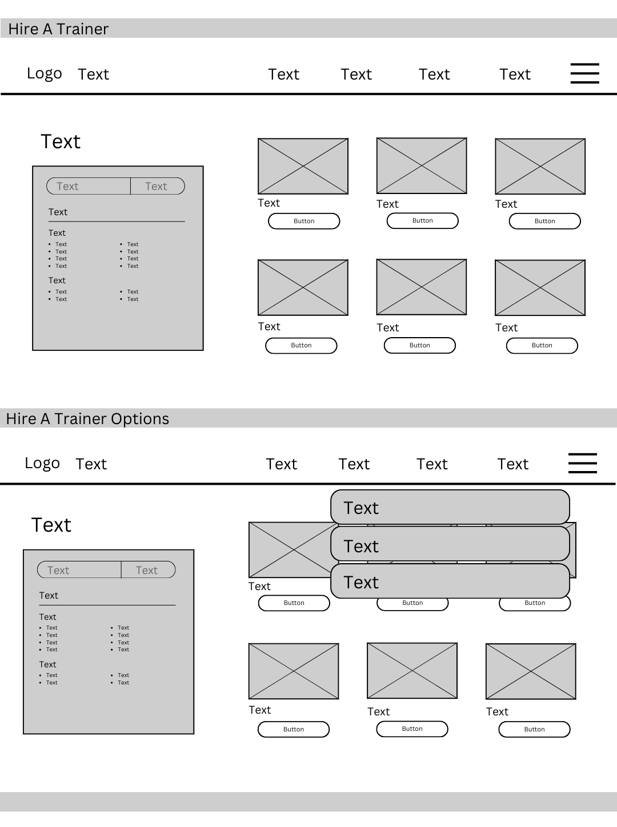

Figure 8. Hire a Trainer Page and Options

This features a grid-based layout with placeholders for ***trainer profiles***. The page likely allows users to browse and select trainers based on their qualifications, specialties, and availability. This page also includes a section for equipment shop options, suggesting that users where the option would be seen

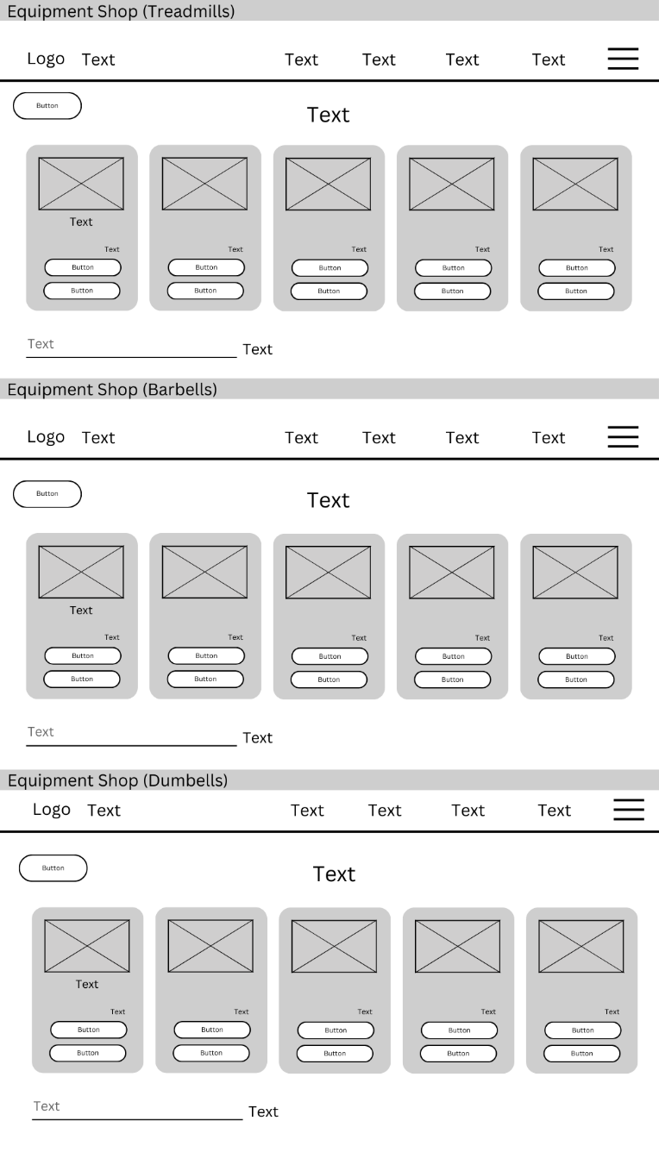

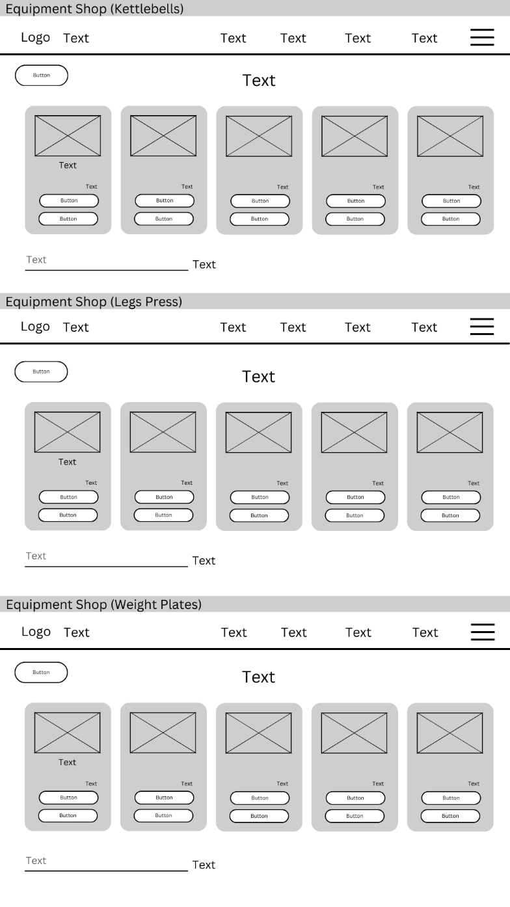

Figure 9. Equipment Shop Page

This features a grid-based layout with placeholders **for *products***. The cards likely represent different fitness equipment items available for purchase, categorized into different sections such as treadmills, kettlebells, barbells, dumbbells, and weight plates.

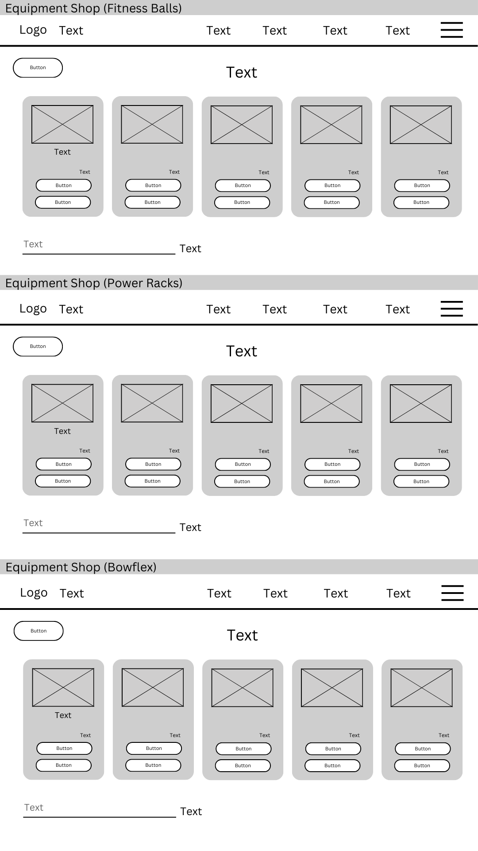

Figure 10. Equipment Shop Page (cont.)

This is the continuation of the equipment shop page. The features are similar grid-based layout in the previous section. The page likely includes additional categories of fitness equipment, such as fitness balls, power racks, and Bow flex machines.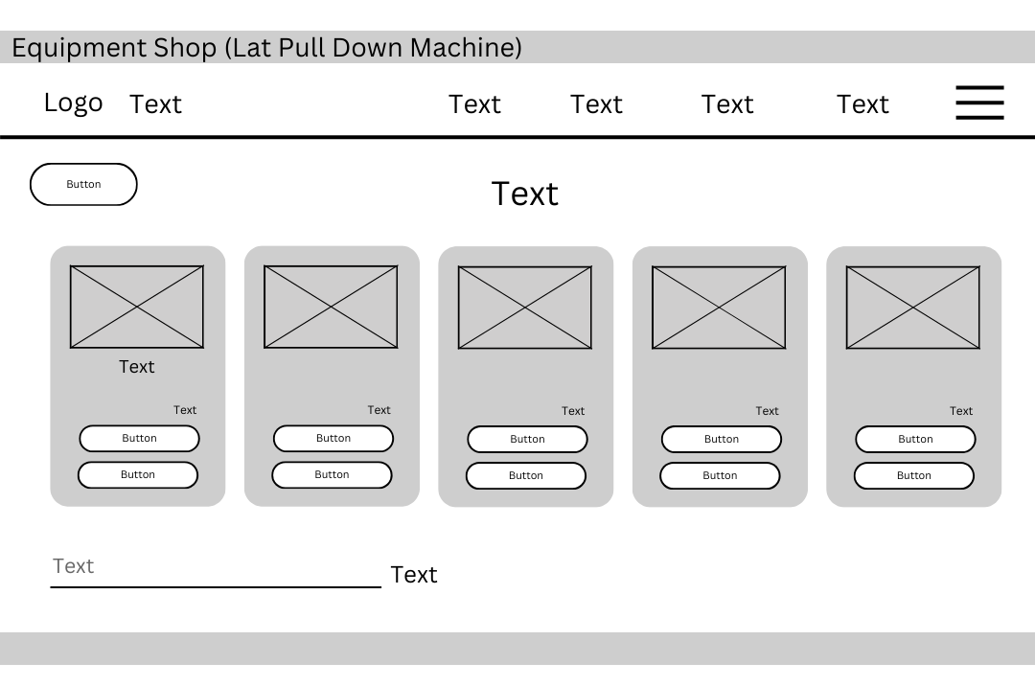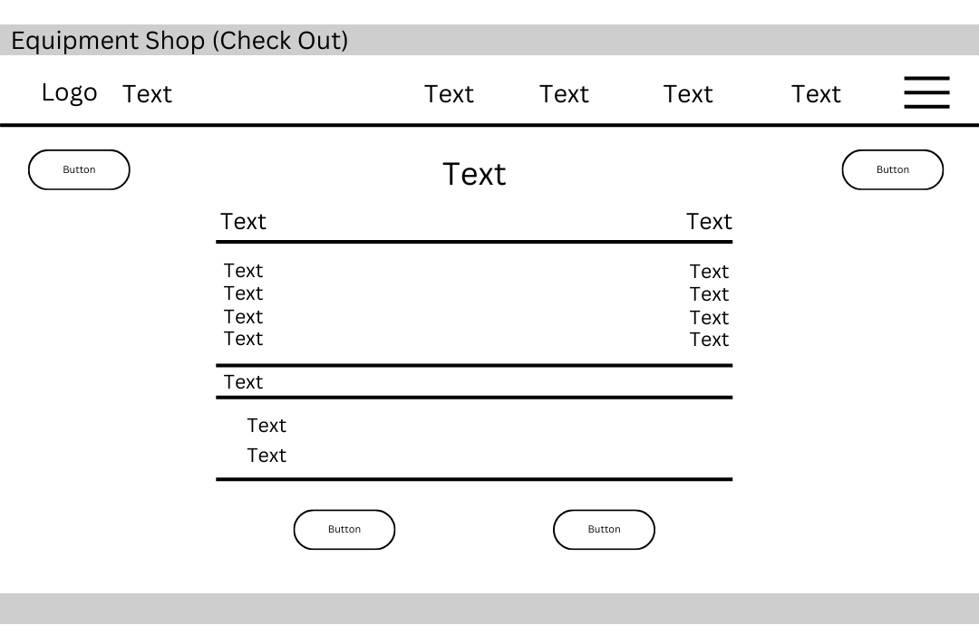

Figure 11. Equipment Shop & Checkout Page

This page likely allows users to view details about a specific piece of equipment, such as the lat pull-down machine, and add it to their cart. The checkout section displays the items purchased, their prices, and the total amount due, allowing users to proceed with the payment process.

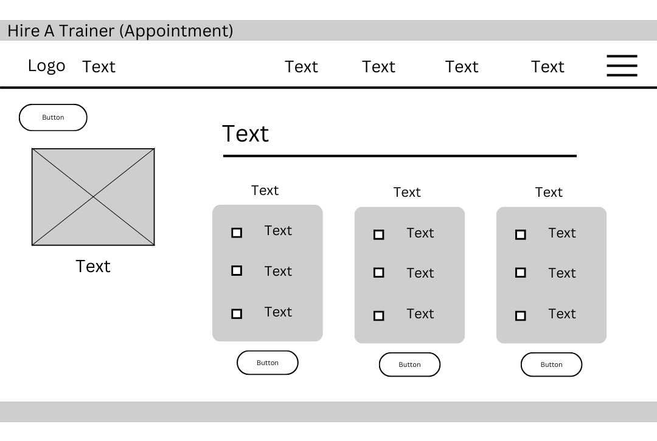

Figure 13. Hire A Trainer (Appointments) Page

This page likely allows users to view available appointment slots for each trainer, select a preferred time, and book an appointment.

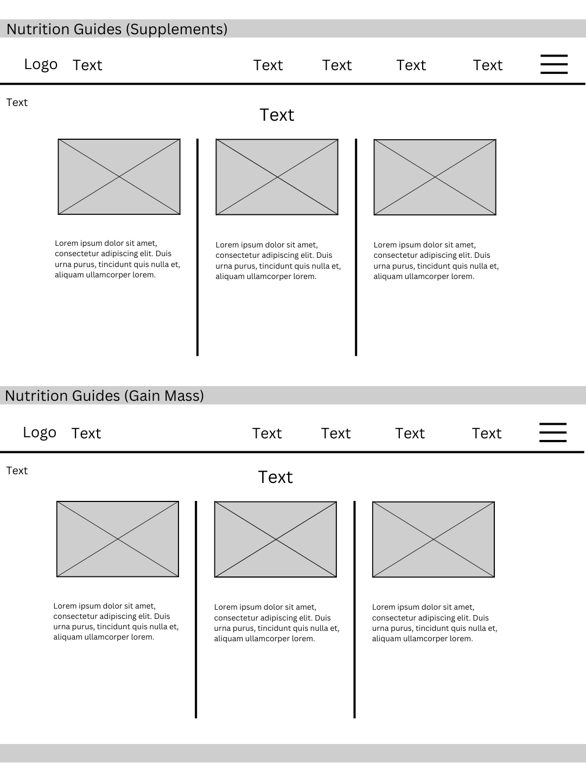

Figure 12. Nutrition Guides Page

The cards likely represent different guides or resources related to nutrition, focusing on supplements or gaining mass.

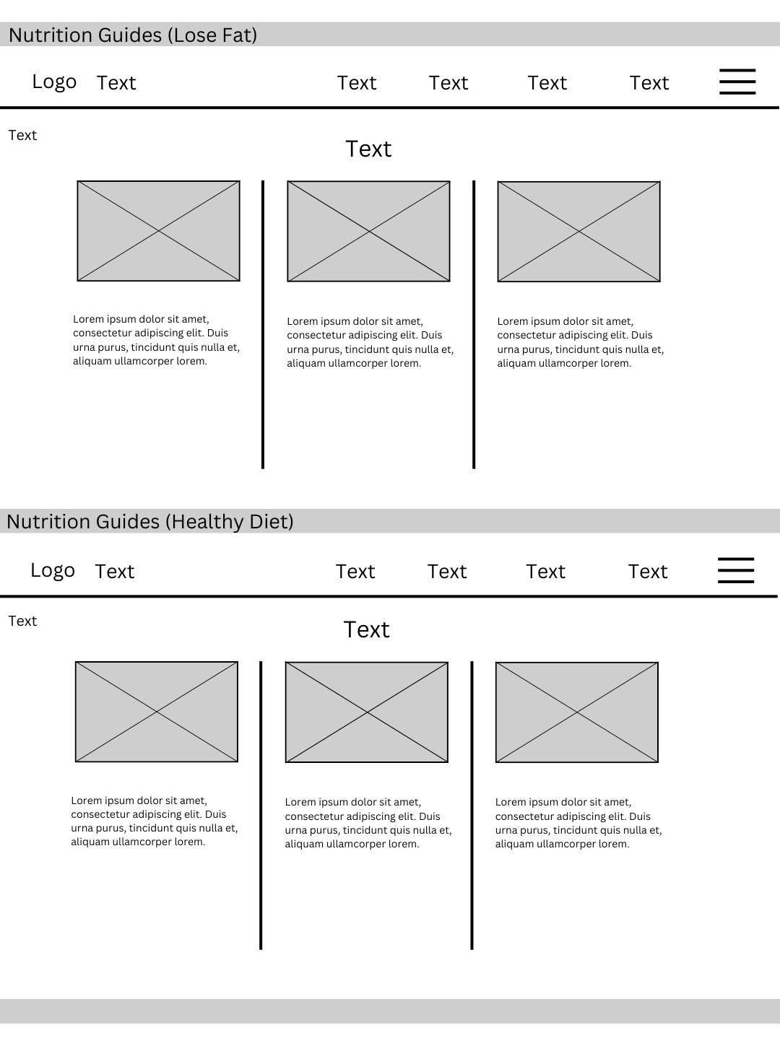

Figure 13. Nutrition Guides Page (cont.)

This page includes additional nutrition guides or resources focused on specific topics, such as losing fat or maintaining a healthy diet.

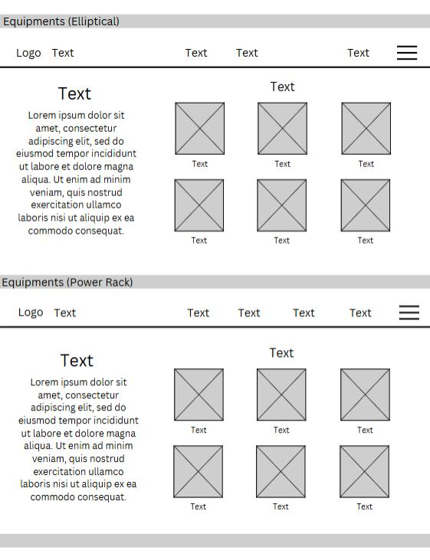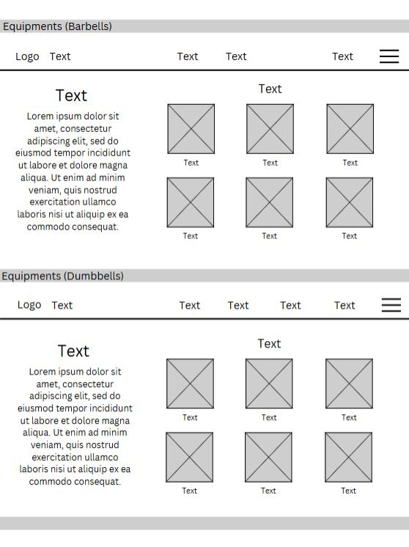

Figure 14. Equipments Information Page

This page includes the equipment comprising Barbells, Elliptical, Dumbbells, Power Racks, Lat Pulldown Machines, Treadmills, Leg Presses, Weight Plates, Fitness Balls, and Kettlebells. It also includes the information about the equipment.

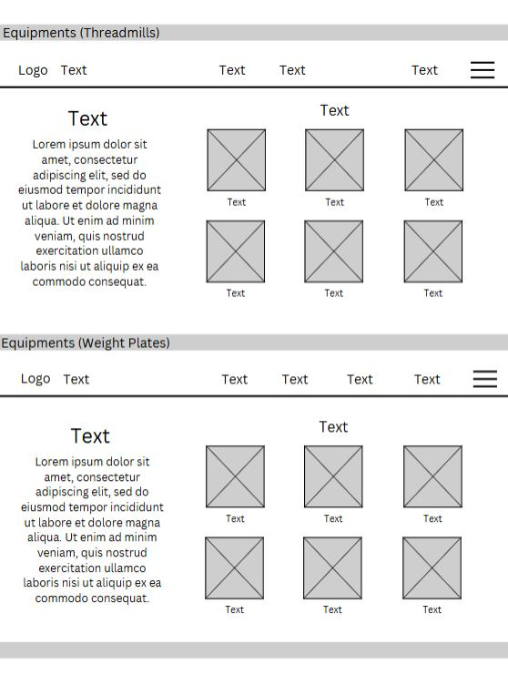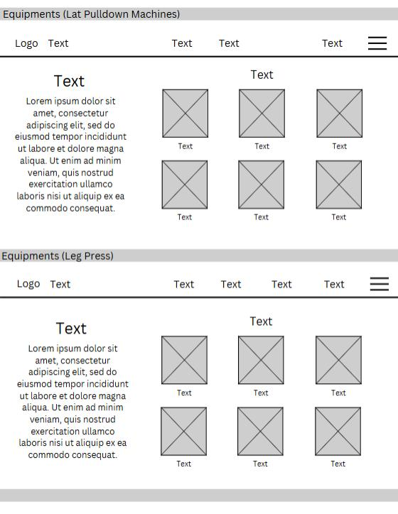

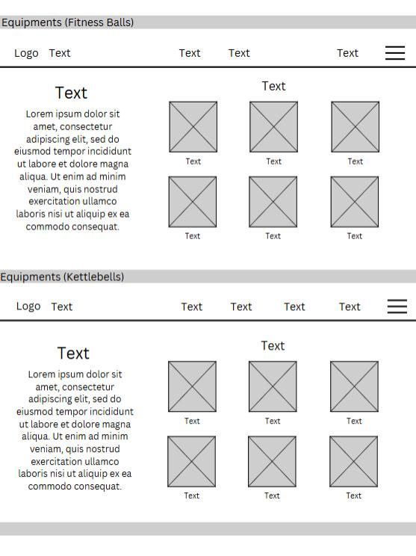Figure 15. Equipments Information Page (cont.)

Figure 16. Equipments Information Page (cont.)

## D.2 Mock-up Design

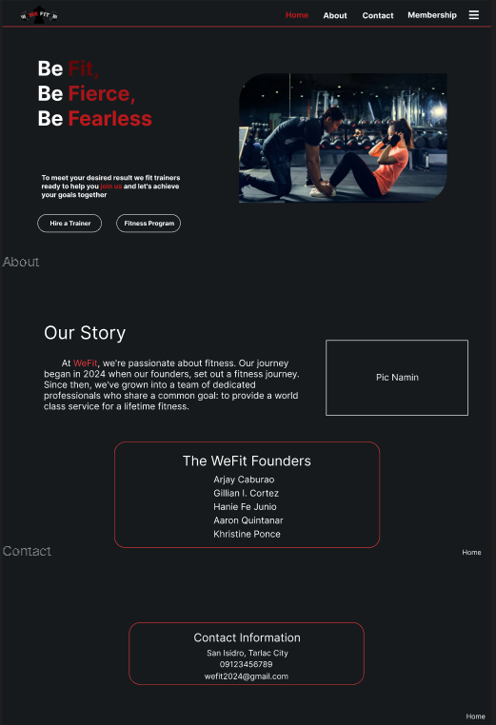

Figure 1. Home page

A visually engaging introduction to our site with the use of high-quality imagery, clear typography, and a consistent color scheme which creates a professional and engaging experience for users.

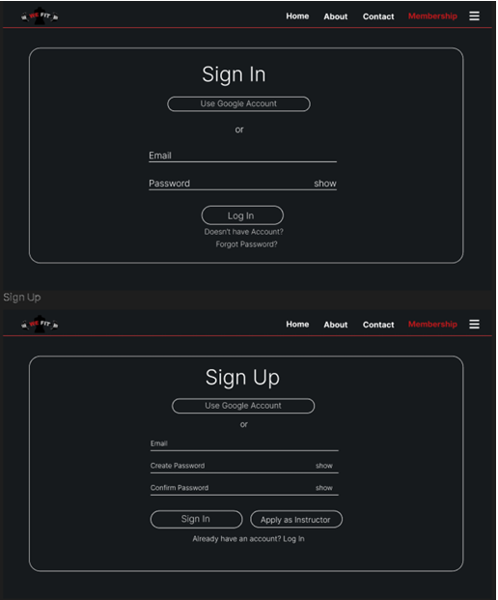

Figure 2. Sign up/Login page

A user-friendly login and registration system that allows returning users to effortlessly access their accounts and provides a seamless experience for new users to join.

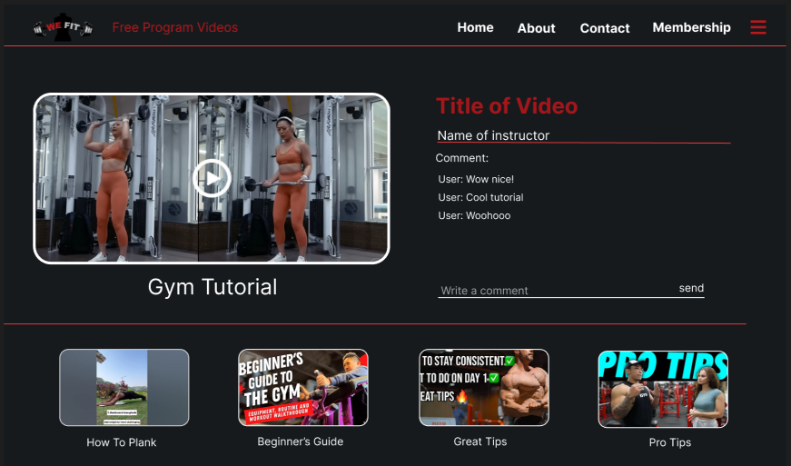

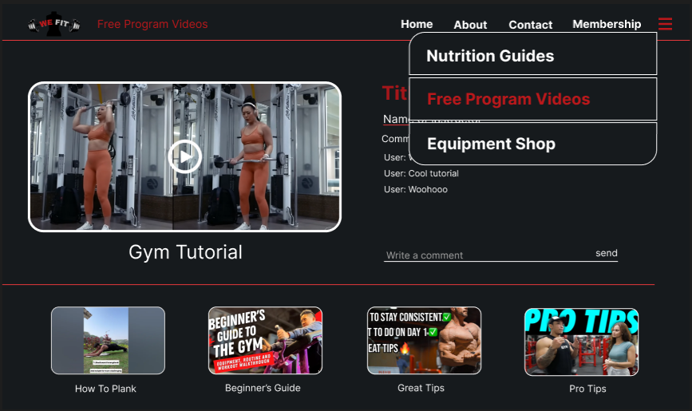

Figure 3. Fitness Program Videos Page

Provides a clear and organized interface for users to easily find and view available videos, with filtering options to narrow down their search. Users can also share their thoughts by leaving comments.

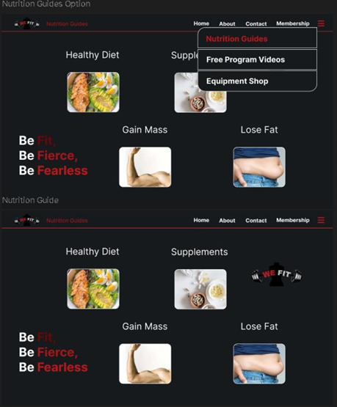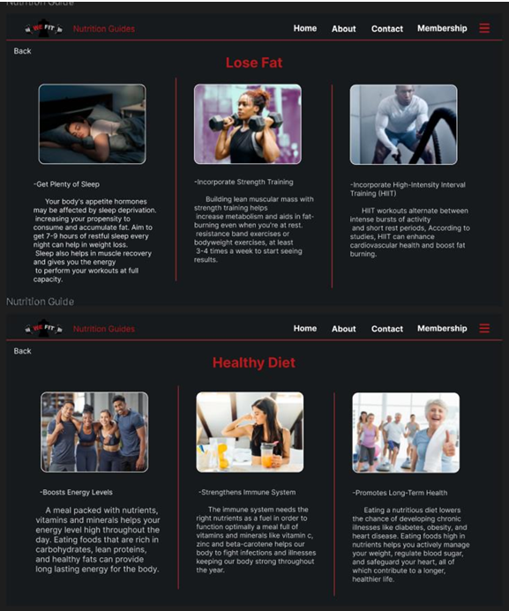

Figure 4. Nutrition Guide Page

This page offers a variety of toolkits for healthy eating, featuring informative guides, practical meal plans, delicious recipes, and helpful tools to support your dietary goals.

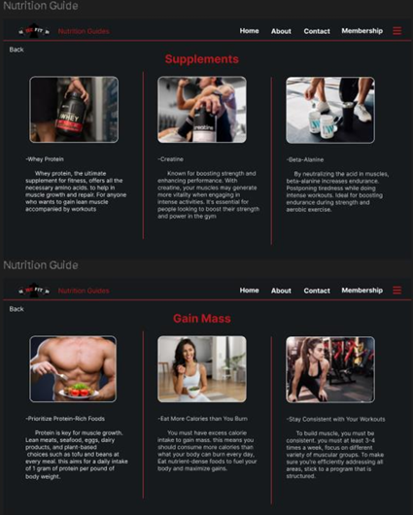

Figure 5. Nutrition Guide Page (cont.)

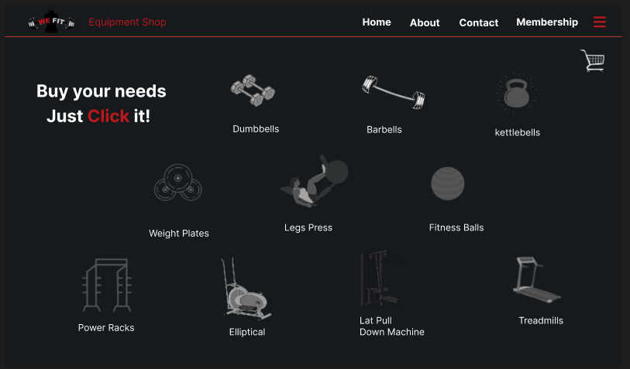

Figure 6. Equipment Shop Page

This page provides a clear overview of the necessary equipment, organized for easy navigation and selection.

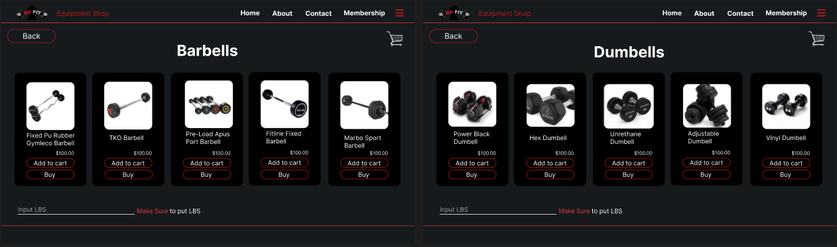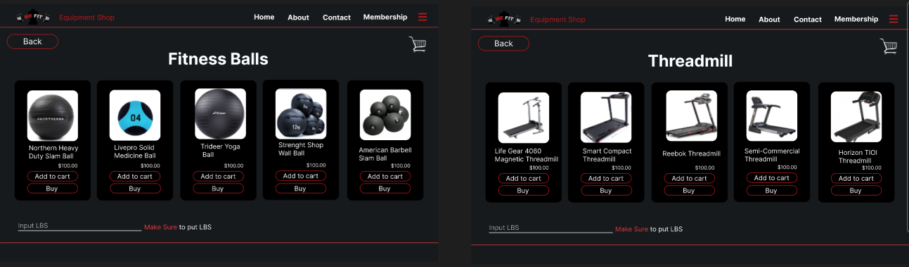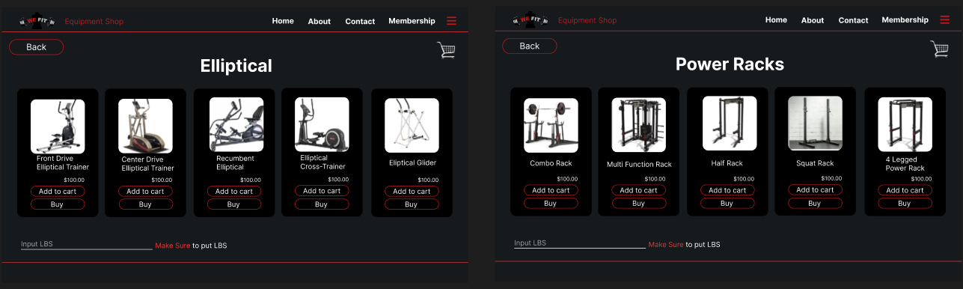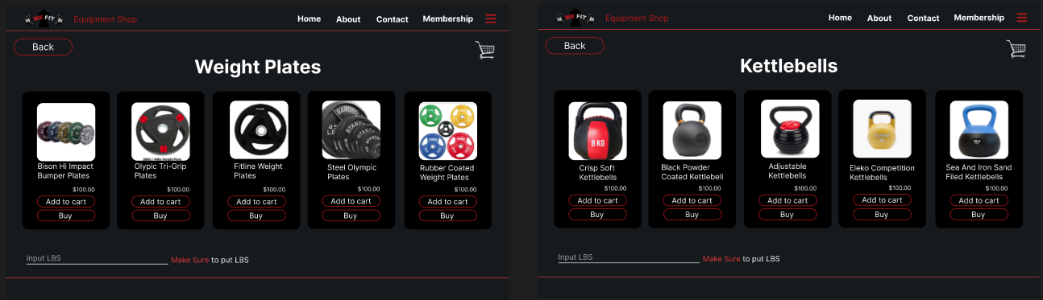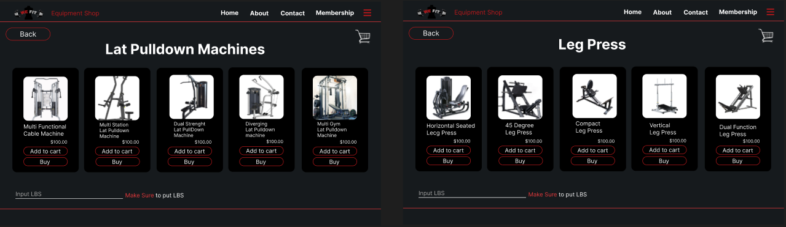

Figure 7. Equipment Shop Page (cont.)

The page showcases a wide selection of fitness equipment to cater to your needs. You can also customize the weights by adjusting the pounds to your preference.

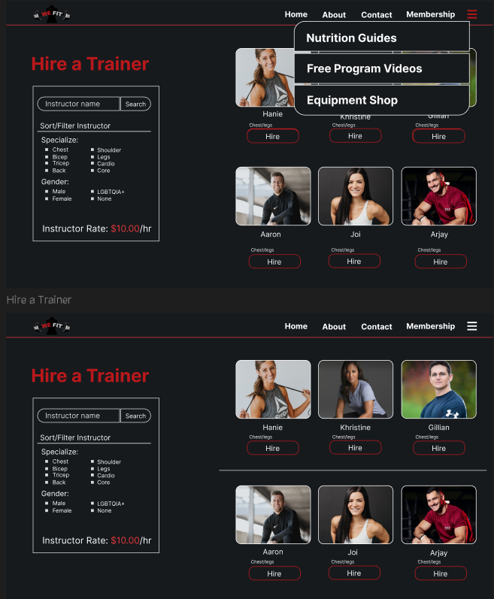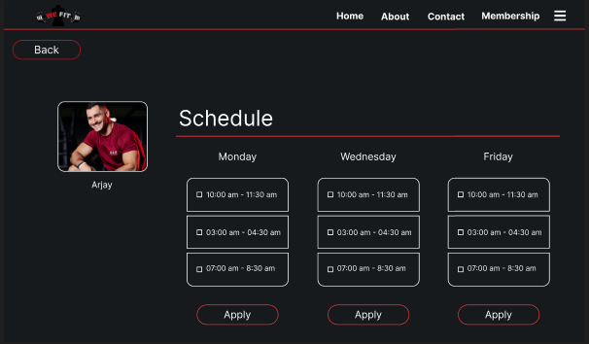

Figure 8. Schedule Page

On this page, users can browse through available trainers and instructors, filter their search based on preferences, and view their schedules to find the best fit for their needs.

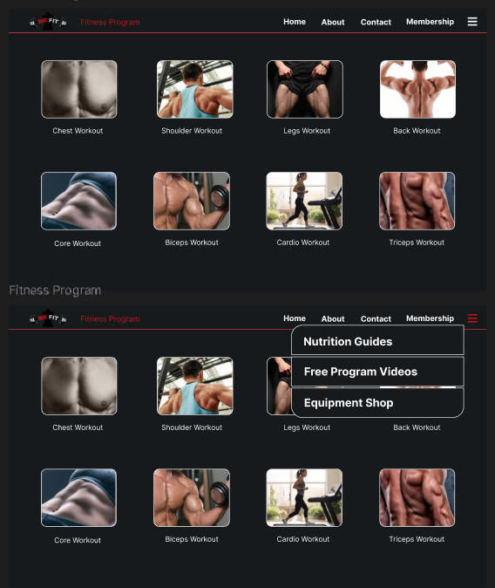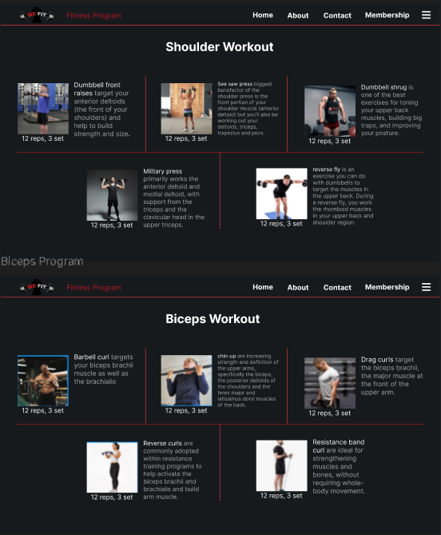

Figure 9. Fitness Program Page

This page offers a personalized workout selection experience, allowing users to choose exercises that address their desired body part goals and provides in-depth information about each option.

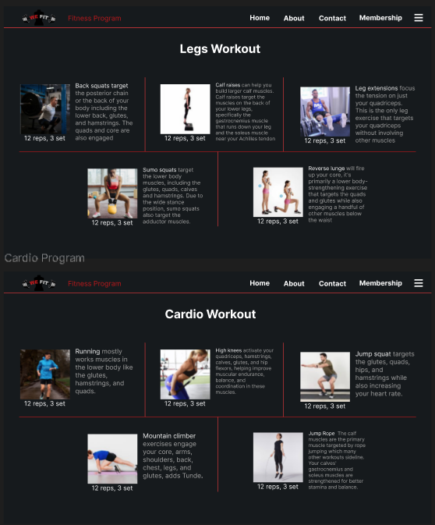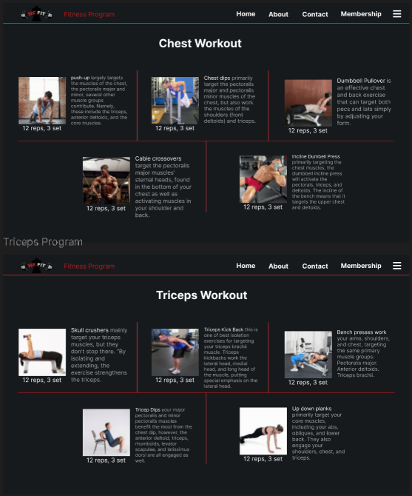

Figure 10. Fitness Program Page (cont.)

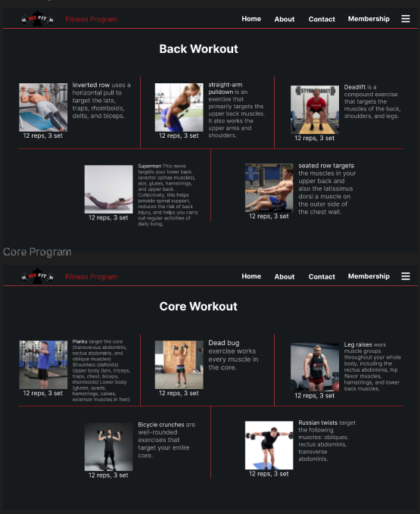

Figure 11. Fitness Program Page (cont.)

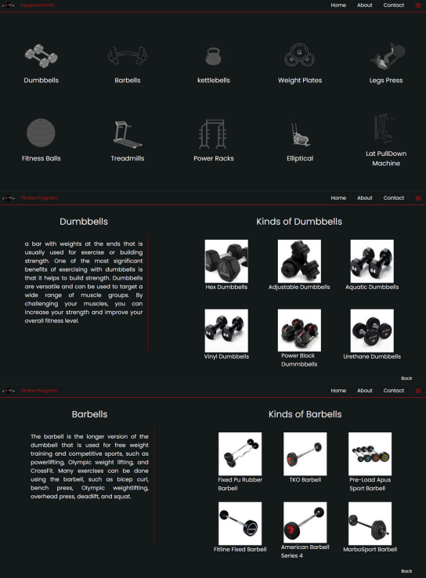

Figure 12. Equipment Information Page

This page shows the final page for the equipment information page. It briefly describes and displays various equipment options with images and descriptions. This design also helps users easily navigate and understand the available equipment choices

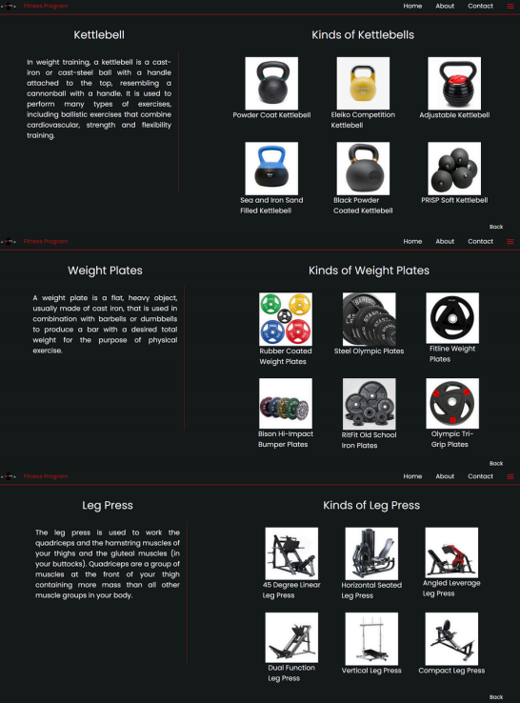

Figure 13. Equipment Information Page (cont.)

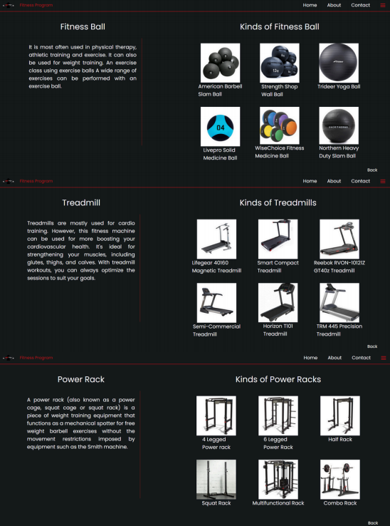

Figure 14. Equipment Information Page (cont.)

.

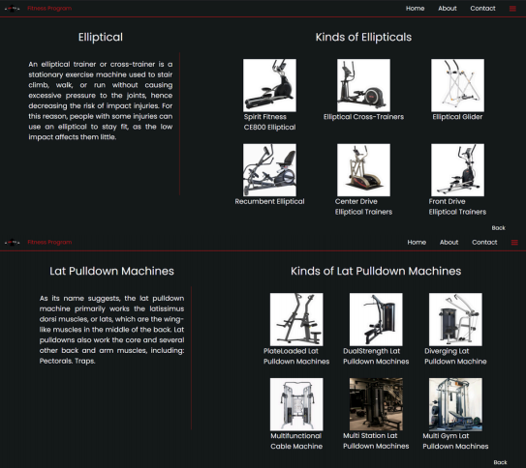

Figure 15. Equipment Information Page (cont.)

References

Ashton Hall. (2024, July 18). FULL LEG WORKOUT | 5 Exercises for Bigger Legs [Video]. YouTube. <https://m.youtube.com/watch?v=csUWMhIwV8c>

Caroline Gurvan. (2020, December 10). 30 MIN PUMPING CARDIO WORKOUT | Full Body – No Equipment at Home [Video]. YouTube. <https://m.youtube.com/watch?v=kZDvg92tTMc>

Fit Media Channel. (2023, January 28). Top Trainers Agree, These are the 10 Best Exercises for Building a Bigger Back [Video]. YouTube. <https://m.youtube.com/watch?v=zgfcOWuTeYA>

Fitness in gym. (2023, September 28). Shoulder Workout – The best video on YouTube for shoulder building [Video]. YouTube. <https://m.youtube.com/watch?v=mCmojndsXeg>

NEXT Workout. (2022, July 25). 5-Minute Chest Workout at Home: Build Muscle Without Equipment [Video]. YouTube. <https://m.youtube.com/watch?v=O9K0k7fzrqU>

Oliver Sjostrom. (2024, June 6). 10 MIN ABS WORKOUT – At Home Sixpack Ab Routine (No Equipment) [Video]. YouTube. <https://m.youtube.com/watch?v=E4BpA2jCB2g>

THE GYM. (2024, September 10). 7 Effective Biceps Exercises At Gym – Biceps Workout [Video]. YouTube. <https://m.youtube.com/watch?v=JeEYrx_zVyM>

TIFF x DAN. (2023, July 10). 10 Minute Tricep Workout at Home with Dumbbells & Bodyweight [Video]. YouTube. <https://m.youtube.com/watch?v=5kstCo2lZW0>